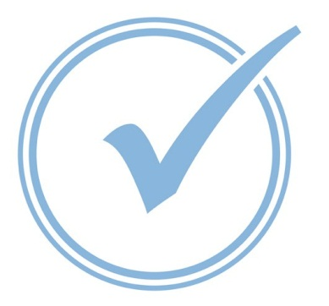
Florida’s 2015-2016
ESE Parent Survey
February 1 – May 31

We need your help to make Florida’s 2015-2016 ESE Parent Survey a record success

Each year, the Florida Department of Education (FDOE) surveys parents of children with an individual educational plan (IEP) to determine how well your child’s school is partnering with you and promoting your involvement in your child’s education. All states must collect this data as part of their State Performance Plan, as required under the Individuals with Disabilities Education Act (IDEA).

✓The web-based survey will open February 1, 2016.
✓You can complete the survey online at http://www.esesurvey.com
or request a paper survey from your child’s school.

Your feedback is important in helping the state and local school systems continue improving educational programs for children with special needs. Thank you!

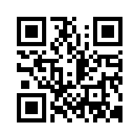
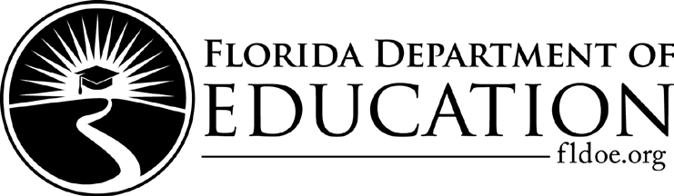
For questions about the survey,
please contact Aimee Mallini at FDOE 850-245-0916
Aimee.Mallini@fldoe.org
Bureau of Exceptional Education and Student Services

