Port St. Joe Elementary School- Title I
Dolphin News
Week of November 21 – November 25, 2016 Mrs. Joni Mock, Principal

Color photo of PSJES Blue Dazzlers will be featured each week in THE STAR!
IMPORTANT DATES TO REMEMBER:
NOVEMBER
21-No Title One Tutoring
22-Half Day (breakfast, no lunch) No 21st CCLC
Sixth Grade Turkey Trot
23-25-Thanksgiving Holidays
29-Scholastic Book Fair Family Night/Science Fair
28 - Dec 2–Book Fair
DECEMBER
6-SAC Meeting
14-College T-Shirt Day
19-SOAR Crafts & Cocoa Party
20-Half Day (breakfast, no lunch)/No 21st CCLC/
End of Second Nine Weeks
Dec 21 - Jan 3- Christmas Holidays
JANUARY
4 Students Return
6-AR Party
12-Report Cards
16-Martin Luther King, Jr. Holiday

Scholastic Book Fair Family Night/ Science Fair
November 29th
PTO will be serving dinner again this year from 5:00 – 7:00 pm
Volunteers are needed to help serve.
Contact Stephanie Petersen at Stephaniepetersen777@yahoo.com
if you will be available to help.
Parents and teachers are needed to make chili and desserts. Donations of hotdogs and buns, chips, crackers, and drinks are needed.
Please sign up for an item to help make Family Night a success!
www.signupgenius.com/go/904054DA4A722A31-family

2016 Big Bend Football League Super Bowl
Saturday, November 19, PSJ Shark Stadium
Pee Wee Division
10:00 Chattahoochee Yellow Jackets vs
Blountstown Tigers
Tiny Mite Division
11:00 Port St. Joe Jaguars vs Blountstown Tigers
Teeny Mite Division
12:00 Port St. Joe Dolphins vs Blountstown Tigers
Congratulations PSJ on a winning season!

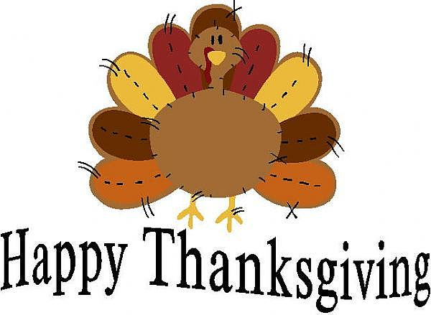

No Lunch
No Lunch
No Lunch
No Lunch
Beef Stew
Potatoes & Peas
Green Beans
Applesauce
Rolls
Milk

Lunch Menu November 21 – November 25 Menu Subject to Change
MONDAY TUESDAY WEDNESDAY THURSDAY FRIDAY

