Port St. Joe Elementary School- Title I
Dolphin News
Week of December 12 – December 16, 2016 Mrs. Joni Mock, Principal

Color photo of PSJES Blue Dazzlers will be featured each week in THE STAR!
IMPORTANT DATES TO REMEMBER:
DECEMBER
14-College T-Shirt Day
16-Kindergarten Gingerbread Houses & Polar Express Movie
19-SOAR Crafts & Cocoa Party/Tacky Christmas Sweater Day/No Title One Tutoring
20-Half Day (breakfast, no lunch)/No 21st CCLC/
End of Second Nine Weeks
First Baptist Church Children’s Christmas Program
Dec 21 - Jan 3- Christmas Holidays
January
4 Students Return
6-AR Party
12-Report Cards
16-Martin Luther King, Jr. Holiday
18-College Shirt Day
20-Gold Cards
23 - 27-Celebrate Literacy Week

Hour of Code
Monday, December 12, 2016 from 3:30-5:00
Corinne Costin Gibson Memorial Public Library
Free for Ages 7 & up
Learn the basics of computer Science and how to create with code.
Bring your own device (laptop or tablet) or use one of ours.
Email RhythmicCoders@gmail.com or
Nancy Brockman at nbrockman@nwrls.com
or call (850) 229-8879

Congratulations PSJES Science Fair Winners!
1st place Ella Dimitrijevich,
2nd Haley Mork, 3rd Rilan Butler
Honorable Mention- Samantha Childers,
Brooke White, Elyse Williams, and Mario Larry

Check out PSJES’s
Pebblego Biographies & Pebblego Science
Username: psjes
Password: psjes
Special thanks to Donna Thompson for writing the grant for these new, awesome databases!

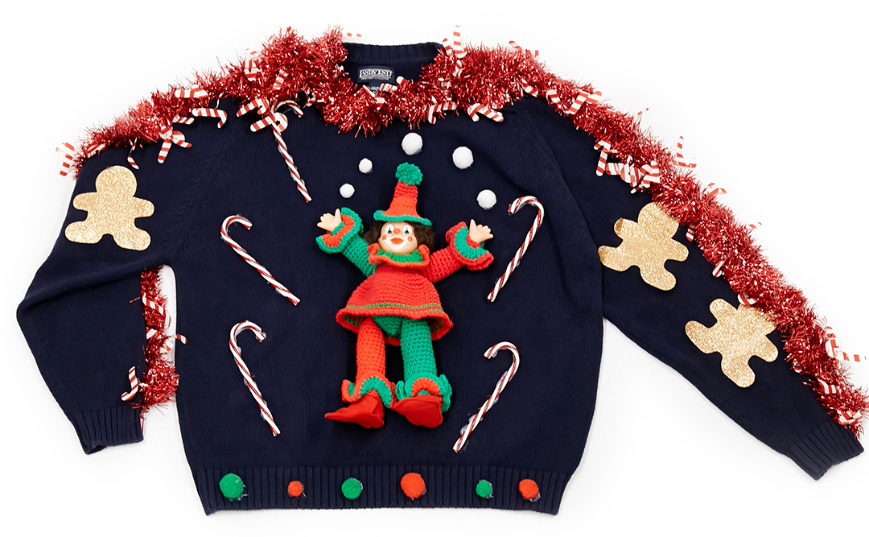
If you completed an application for the Bikes for Boys and Girls Program, please be aware that bikes will be given out on December 17, at 10 A.M. at City Commons next to City Hall.
Tacky Christmas Sweater Day
Monday, December 19th

Lunch Menu December 12 – December 16 Menu Subject to Change
MONDAY TUESDAY WEDNESDAY THURSDAY FRIDAY

BBQ Turkey on Bun
Tater Tots
Pineapple Chunks
Cole Slaw
Ketchup
Milk
Beef Stew
Potatoes & Peas
Green Beans
Applesauce
Rolls
Milk
Chicken & Noodles
Green Beans
Carrots
Pears
Rolls
Milk
Beef-A-Roni
Steamed Broccoli
Garlic Toast
Sliced Apples
Milk
Chicken, Oven
Rice
Turnip Greens
Brown Gravy
Hush Puppy
Applesauce
Milk

