Port St. Joe Elementary School- Title I
Dolphin News
Week of December 19 – December 23, 2016 Mrs. Joni Mock, Principal

Color photo of PSJES Blue Dazzlers will be featured each week in THE STAR!
IMPORTANT DATES TO REMEMBER:
DECEMBER
19-SOAR Crafts & Cocoa Party/Tacky Christmas Sweater Day/No Title One Tutoring
20-Half Day (breakfast, no lunch)/No 21st CCLC/
End of Second Nine Weeks
First Baptist Church Children’s Christmas Program
Dec 21 - Jan 3- Christmas Holidays

January
4 Students Return
6-AR Party
12-Report Cards
16-Martin Luther King, Jr. Holiday
18-College Shirt Day
20-Gold Cards
23 - 27-Celebrate Literacy Week

Have a very Merry Christmas and a Happy New Year
PSJES!

Remember that students return on January 4, 2017

Congratulations PSJES Science Fair Winners!
1st place Ella Dimitrijevich,
2nd Haley Mork, 3rd Rilan Butler
Honorable Mention- Samantha Childers,
Brooke White, Elyse Williams, and Mario Larry

Check out PSJES’s
Pebblego Biographies & Pebblego Science
Username: psjes
Password: psjes
Special thanks to Donna Thompson for writing the grant for these new, awesome databases!

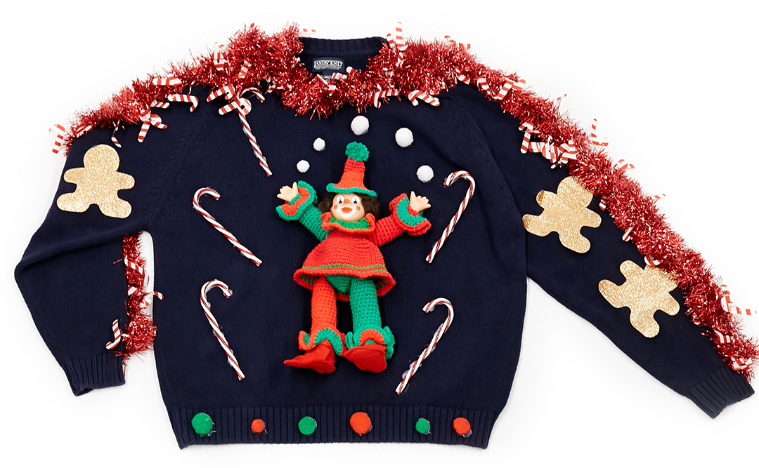
If you completed an application for the Bikes for Boys and Girls Program, please be aware that bikes will be given out on December 17, at 10 A.M. at City Commons next to City Hall.
Tacky Christmas Sweater Day
Monday, December 19th

Lunch Menu December 19 – December 23 Menu Subject to Change
MONDAY TUESDAY WEDNESDAY THURSDAY FRIDAY

Pizza w/Pork Topping
Green Peas
Garden Salad
Ranch Dressing
Ketchup
Pears
Milk
Holiday
Holiday
Holiday
No Lunch

